**6.1.2023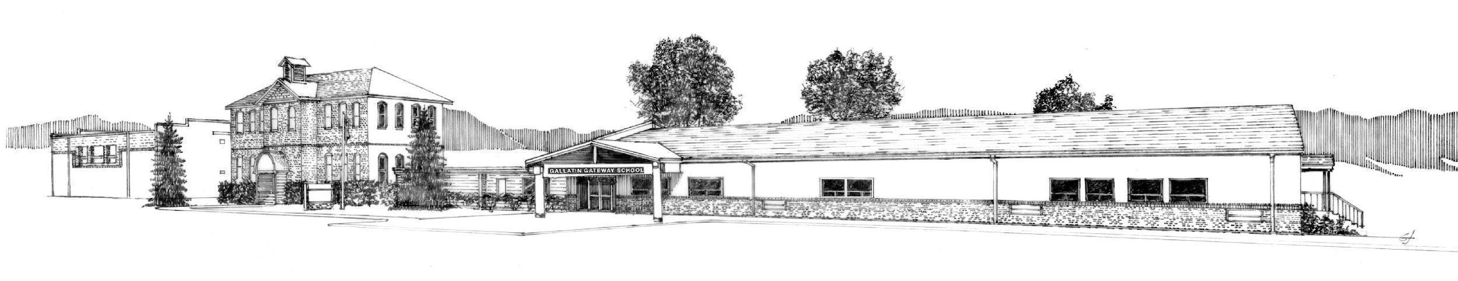 Agenda**

**Special Meeting of Trustees**

**AMENDED**

The special committee meeting of the Board of Trustees of School District #35 has been scheduled for **June 1, 2023** at **10:00 A.M.** **in the boardroom.**

**Call to Order**

**Public Comment - Non Agenda Items** 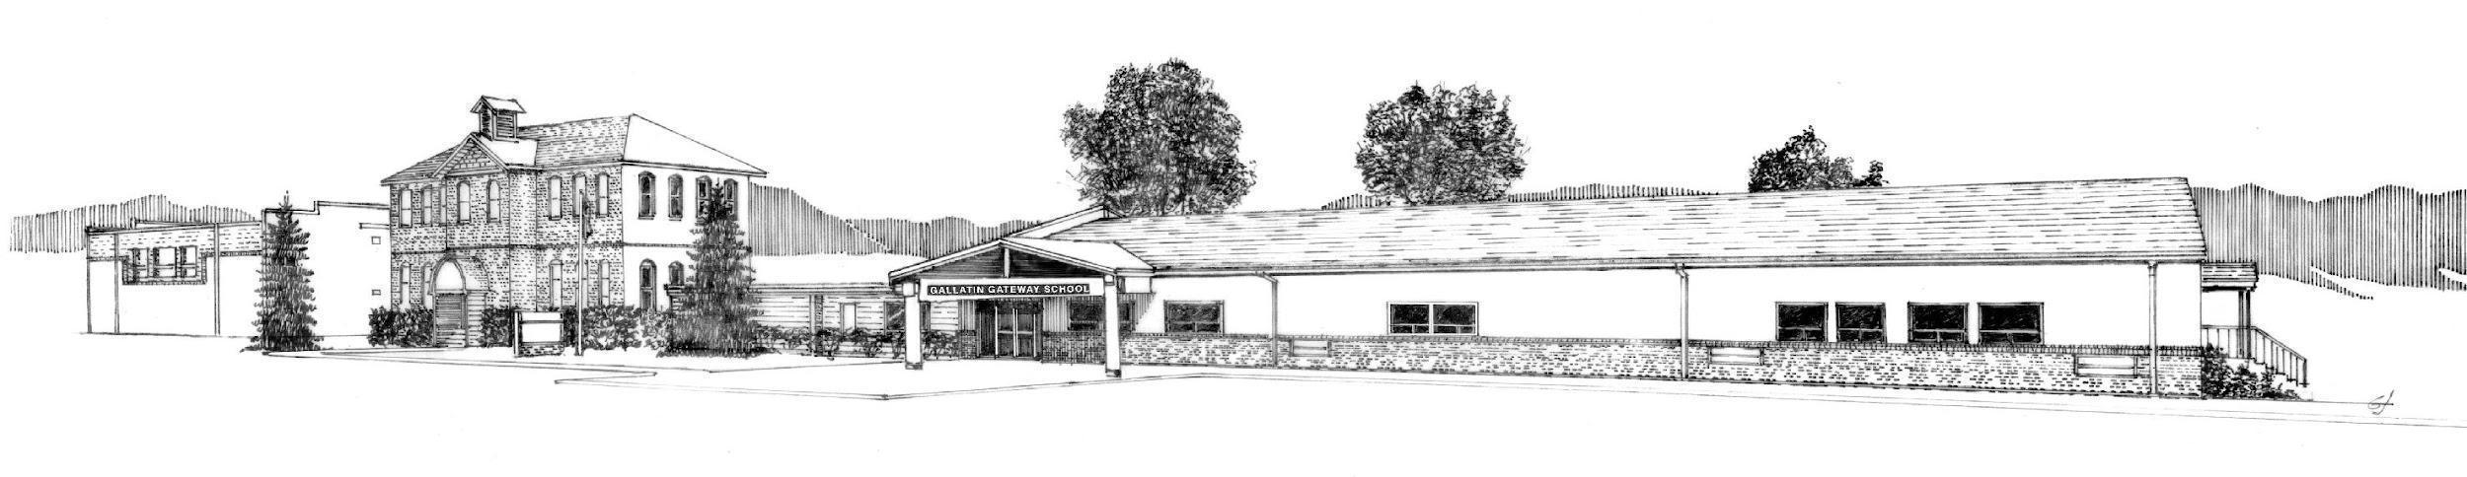

**New Business**

*Discussion Items*

Bond Information

*Action Items*

Intercap Loan

Owners Rep RFQ

Resolution to dispose of abandoned, obsolete, and undesirable property - 20-6-604, MCA

**Adjournment**